SIMATS ENGINEERING
ASSESSMENT TOOL 1

COURSE NAME: INTERNET PROGRAMMING
COURSE CODE: CSA4308
Name: V Aswini Pavan Kumar
Register Number: 192372151

1: Online Symposium Portal
A college is developing an online symposium registration portal. The following HTML
structure and HTTP interaction is observed:
&lt;form action=&quot;/register&quot; method=&quot;POST&quot;&gt;
&lt;input type=&quot;text&quot; name=&quot;name&quot;&gt;
&lt;input type=&quot;email&quot; name=&quot;email&quot;&gt;
&lt;button&gt;Submit&lt;/button&gt;
&lt;/form&gt;
When a student submits the form, the browser sends an HTTP request to the server, and the
server responds accordingly.
Questions:
- Identify appropriate HTML5 semantic elements missing in the structure.
<header> – Displays the page title.
<main> – Contains the main content.
<section> – Groups the registration form.
<label> – Describes each input field.
<footer> – Displays footer information.

- Modify the structure to make it standards-compliant.
<!DOCTYPE html>
<html lang="en">
<head>
<meta charset="UTF-8">
<meta name="viewport" content="width=device-width, initial-scale=1.0">
<title>Online Symposium Registration</title>
</head>
<body>
<header>
<h1>Online Symposium Registration</h1>
</header>
<main>
<section>
<h2>Registration Form</h2>
<form action="/register" method="POST">
<label for="name">Name:</label>
<input type="text" id="name" name="name" required>
<br><br>
<label for="email">Email:</label>
<input type="email" id="email" name="email" required>
<br><br>
<button type="submit">Submit</button>
</form>
</section>
</main>
<footer>
<p>&copy; 2026 College Symposium</p>
</footer>
</body>
</html>
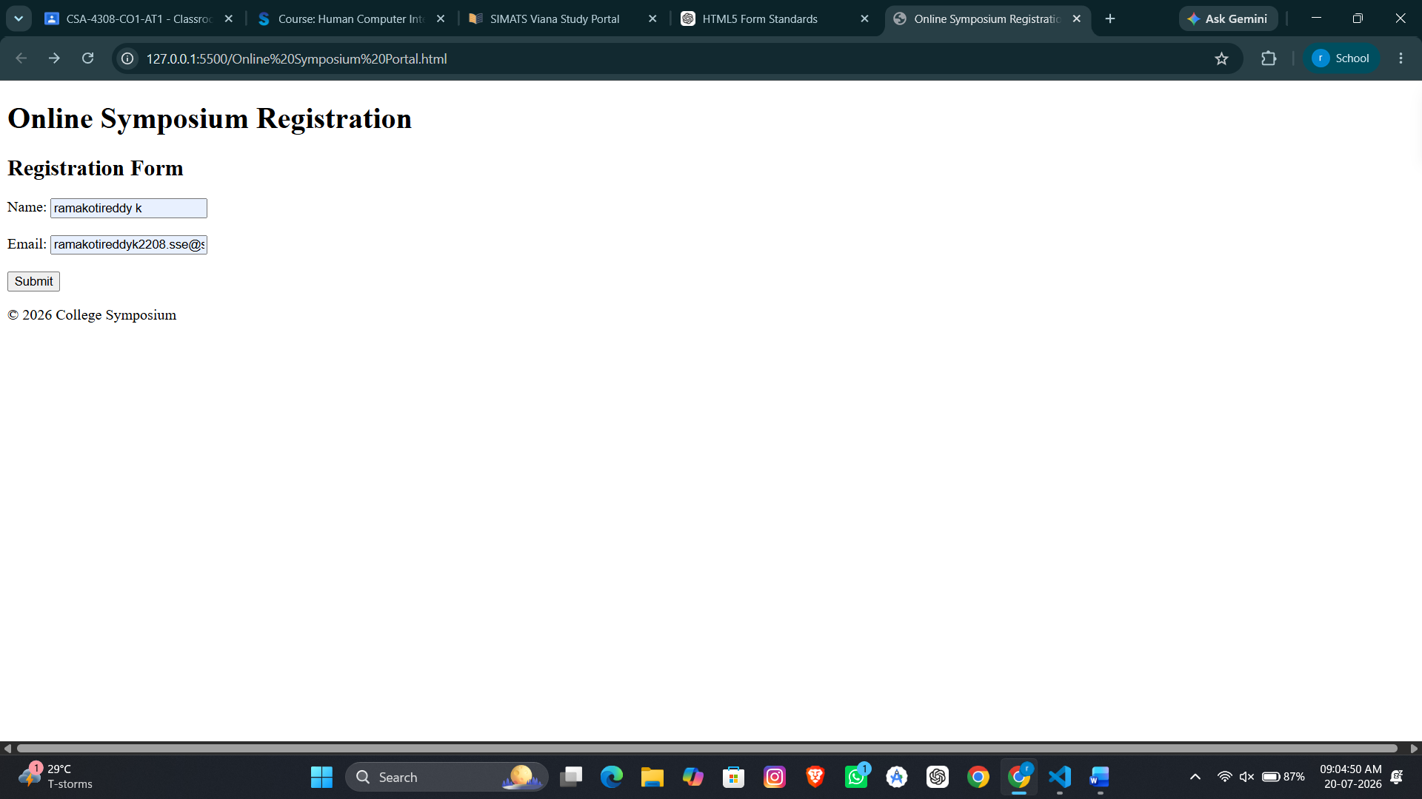

- Interpret the HTTP request generated during form submission.

POST /register HTTP/1.1
Host: 127.0.0.1:5500
Content-Type: application/x-www-form-urlencoded name=ramakotireddy+k&email=ramakotireddyk2208.sse

- Analyze the HTTP response cycle from server to browser.

User fills the form
↓
Browser sends POST request
↓
Server receives the request
↓
Server validates the data
↓
Server stores the registration
↓
Server sends HTTP response
↓
Browser displays success page

5. Suggest improvements for usability and accessibility.
- Use semantic tags (<header>, <main>, <section>, <footer>).
- Add <label> for every input field.
- Use the required attribute for mandatory fields.
- Specify type="submit" for the button.
- Add placeholders to guide users.
- Display validation error messages.
- Ensure keyboard navigation.
- Maintain sufficient color contrast.
- Use responsive design (<meta name="viewport">).
- Use ARIA attributes when necessary.

2: Cross-Browser Compatibility Issue

A company website shows inconsistent layout across browsers. The following HTML snippet
is used:
&lt;html&gt;
&lt;head&gt;
&lt;title&gt;Company&lt;/title&gt;
&lt;/head&gt;
&lt;body&gt;
&lt;div&gt;
&lt;h1&gt;Welcome
&lt;p&gt;About us
&lt;/div&gt;
&lt;/body&gt;
&lt;/html&gt;

Questions:
- Identify improper nesting and missing closing tags.
The original HTML has the following issues:
  - <h1> is not closed using </h1>.
  - <p> is not closed using </p>.
  - The <div> contains improperly nested elements.
  - <!DOCTYPE html> is missing.
  - The <html> tag does not specify the language using lang="en".
  - These issues may cause browsers to interpret the page differently.

- Analyze how different browsers may interpret this structure.
Different browsers have different HTML parsing engines.
- Some browsers automatically insert missing closing tags.
- Other browsers may display the content with incorrect formatting.
- Improper nesting can result in inconsistent layouts.
- Fonts, spacing, and element positioning may vary across browsers.
- Modern browsers try to fix HTML errors, but the output may still differ.
Therefore, invalid HTML can produce inconsistent layouts on different browsers.

- Identify missing semantic elements (e.g., header, section).
The following HTML5 semantic elements are missing:
- <header> – Contains the page heading.
- <main> – Contains the main content.
- <section> – Groups related content.
- <footer> – Displays footer information.
Using semantic elements improves readability, accessibility, and SEO.

- Provide a corrected W3C-compliant HTML structure.
The corrected HTML structure includes:
  - <!DOCTYPE html>
  - <html lang="en">
  - <meta charset="UTF-8">
  - <meta name="viewport">
  - Proper opening and closing tags.
  - HTML5 semantic elements (<header>, <main>, <section>, <footer>).
  - Proper nesting of all HTML elements.
This structure follows W3C HTML5 standards and is compatible with modern browsers.

- Suggest techniques to ensure cross-browser compatibility.
  - Write valid HTML5 and CSS3 code following W3C standards.
  - Properly close and nest all HTML elements.
  - Use semantic HTML elements.
  - Test the webpage in multiple browsers such as Chrome, Firefox, Edge, and Safari.
  - Use the <!DOCTYPE html> declaration.
  - Use CSS resets or normalize stylesheets for consistent rendering.
  - Use responsive design with the viewport meta tag.
  - Validate HTML and CSS using W3C validation tools.
  - Avoid browser-specific features unless necessary.

OUTPUT:

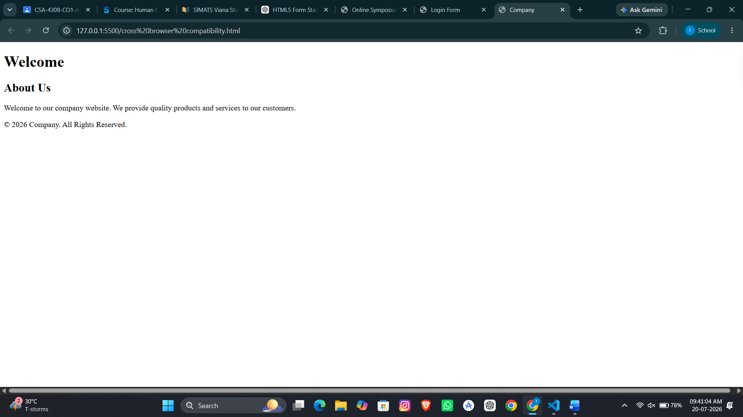

3: Form Submission Failure
A web application fails to send form data to the server. The following configuration is
observed:
&lt;form action=&quot;/submit&quot; method=&quot;GET&quot;&gt;
&lt;input type=&quot;text&quot; name=&quot;username&quot;&gt;
&lt;input type=&quot;password&quot; name=&quot;password&quot;&gt;
&lt;button type=&quot;button&quot;&gt;Login&lt;/button&gt;
&lt;/form&gt;

Questions:
- Identify issues in the form configuration.
The original form has the following issues:
- The button uses type="button" instead of type="submit", so the form is not submitted.
- The GET method is used for sending the username and password, which is not secure.
- <label> elements are missing for the input fields.
- The input fields do not use the required attribute.
- HTML5 semantic elements such as <header>, <main>, and <section> are not included.

- Analyze why the HTTP request is not triggered.
In the original form, the Login button is defined as:
<button type="button">Login</button>.
A button with type="button" does not submit the form automatically. Therefore, clicking the Login button does not generate an HTTP request. After correcting it to type="submit", the browser sends the request. In your output, clicking Login sends a POST request, but Live Server returns HTTP ERROR 405 because it cannot process POST requests without a backend server.

- Interpret the role of GET method in this scenario.
The username and password become part of the URL, making them visible in the browser history, bookmarks, and server logs. Therefore, GET is not suitable for login forms or any sensitive information. The POST method should be used instead.

- Propose a corrected implementation.
  - The corrected implementation includes the following changes:
  - Change the form method from GET to POST.
  - Change the button type from button to submit.
  - Add <label> elements for better accessibility.
  - Add the required attribute to make fields mandatory.
  - Use HTML5 semantic elements such as <header>, <main>, <section>, and <footer>.
These changes ensure that the form follows HTML5 standards and submits data correctly.

- Suggest improvements for secure data transmission.
- Use the POST method instead of GET for login forms.
- Use HTTPS to encrypt data between the browser and the server.
- Never send passwords through the URL.
- Validate user input on both the client and the server.
- Store passwords securely using hashing algorithms such as bcrypt or Argon2.
- Protect the application against CSRF (Cross-Site Request Forgery) attacks.
- Use secure session cookies with the HttpOnly, Secure, and SameSite attributes.

OUTPUT:

